### 8/7/2022

**First Christian Reformed Church**

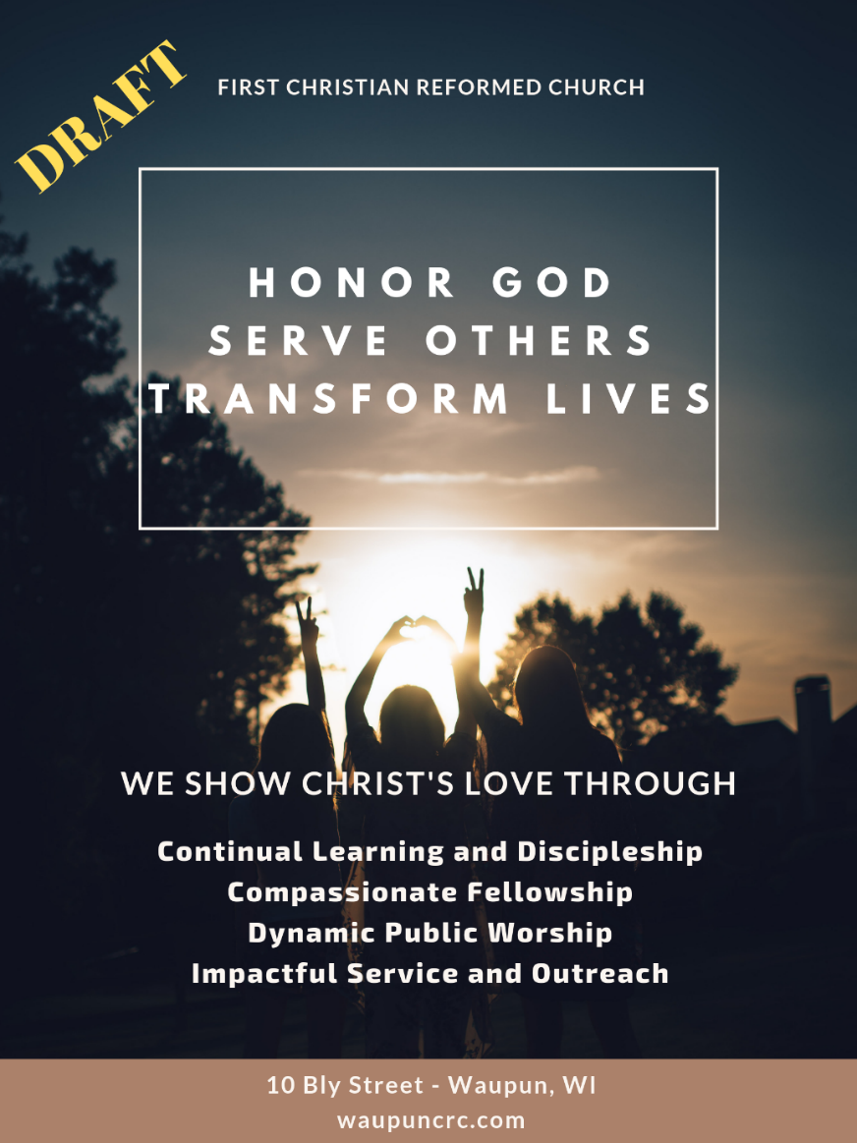

**We welcome our guests** and hope that you will be blessed by worshiping the Lord together with us today. If you are presently seeking a church home, we welcome you to join us here at First CRC! You will find a guest card in your pew. Please fill one out and place it in the offering basket on the table on the way out, so we can reach out to you. If you would like further information about our church, please visit us at [www.waupuncrc.com](http://www.waupuncrc.com/) or call (920-324-2898) or email the church office (waupuncrc@gmail.com). Pastor Greg Schuringa would be happy to connect with you after the service or during the week as well: [pastorgreg@waupuncrc.com](mailto:pastorgreg@waupuncrc.com).

**Large-print bulletins** and **children's bulletins** are available from an usher.

You can watch our services live on Facebook and later from our website as well as view the bulletin there. Website address is [www.waupuncrc.com](http://www.waupuncrc.com)

**Our Core Values:** We show Christ’s love through continual learning and discipleship, compassionate fellowship, dynamic public worship, and impactful service and outreach.



**Office hours: Thursdays, 10 AM to 2 PM**

**All announcements are due in the office by noon Thursday**

**Phone: 920-324-2898 email:** [**waupuncrc@gmail.com**](mailto:waupuncrc@gmail.com)

**PO Box 32, Waupun**

9:30 AM Worship Service

* Please stand if you are able.

Prelude

Welcome and Announcements

Call to Worship (Confession and Assurance)

God’s Greeting

*Songs of Worship: “Our God” “You Are God Alone” “The Solid Rock” R526

Congregational Prayer

*Children ages 3-6 are dismissed for Children’s Worship*

Heidelberg Catechism: Lord’s Day 10 (Q&A 27 and 28)

*Scripture: Proverbs 16:33; Matthew 10:29; Acts 4:23-28;   
Proverbs 3:5-6

Message: “Greatest Hits of the Faith #3: How the Sovereignty of God Makes Your Life Beautiful, Part 1”

Prayer

*Song of Response: “Tis So Sweet to Trust in Jesus” R581:1, 2, 4

Profession of Our Faith: The Apostle’s Creed

Preparing for the Lord’s Supper

Celebrating the Lord’s Supper

*Song of Thanksgiving: “Amazing Grace (My Chains Are Gone)”

*Benediction

*Closing Song: “Benediction”

*Postlude

**Taking part in worship today:**

* Worship Leader and Sermon: Pastor Greg Schuringa
* Worship Leader: Craig Slings
* Worship Team: Greenfield family members
* Media Team: Pete Vander Werff, Cody Van Herwaarden, Gladys Montsma
* Coffee: Al and LeAnne Holden
* Children’s Worship: Emily Mulder, Avery Slings
* Nursery: Jenna Mulder, Jessica Ten Pass, Elise Ritzema
* Ushers: Neil Venhuizen, Brad Schouten

**Missionary Letters**

C Slings to Neen

C Ruis to Chaplain Pete*

+Pray especially for this missionary family this week.

**Giving to First CRC**

If you feel led to give to our church’s ministry, please leave your donation in the basket on the table in the narthex. All loose cash offerings will go to the month’s special offering (ONE Waupun for August), while any loose and undesignated checks will go to the local budget. Budget envelopes will go to the designated funds. On-line giving is also available, just go to our website and click on “Give” at the top of the page. Please talk to a deacon if you want more information about giving to First CRC.

**Our Family**

**As you pray this week, please remember the following:**

* Harold Greenfield, Kathy Kamphuis, Brenda Merhalski, Larry Pluim, and Laura Ten Pass, all dealing with cancer.
* Glen Greenfield was admitted to the Waupun hospital last Sunday to receive IV antibiotics to treat a salmonella infection of unknown origin.
* Wilma Navis as she is unable to worship with us.

**We extend our sympathy to Dewey and Lois Pausma** and family in the sudden passing away of their oldest son, Phil, over the weekend. Visitation is **Tuesday, August 9**, from 4-6 PM at the Werner-Harmsen Funeral Home in Waupun, with a funeral service to follow there at 6 PM.

**There will be birthday cake** after the service today in honor of Bea TeGrootenhuis’ upcoming 90th birthday!

**Church News**

**Upcoming Worship Highlights and dates to remember:**

* August 27 (4-8): Neighborhood Block Party
* August 28 – Outdoor worship
* September 4 – Meditation and Hymn Sing, final Greatest Hits of the Faith message

**Women interested in a Bible Study**, whether it be afternoon or evening, please meet in the front of church on the south side after the morning service TODAY.

**We are in need of a few more ushers**—many bodies make light work! Please let Lois know if you are willing and able to serve in this way.

**Church Email List**: if you are not on the First CRC email list, please contact Lois in the office at [waupuncrc@gmail.com](mailto:waupuncrc@gmail.com) so you can be added. We occasionally send out mid-week church prayer requests and announcements, and would like everyone who wants to, to be able to stay connected to what’s happening at First Church.

**First Facebook and Website**: Whether you are newer to First or a longtime member our Facebook page and website are available to provide important all-church communications and help keep us connected mid-week and when you may miss a Sunday or two. You’ll find our bulletins, videos of our worship services, the church calendar and more. <https://www.facebook.com/1stcrcwaupun> and <https://www.waupuncrc.com>.

**Enjoy having a fun night out with a little chaos, laughter, mentoring and Bible study mixed in?**! Have the gift of gab? Then youth ministry is for you!! We are looking for few high school youth group and middle school SWaT mentors for the coming school year and would love to have you join the team! No experience needed and you’re never too old to mentor. Interested or have questions, please contact Dan Scheuers or Lois Mulder if interested.

**Leadership Development Network:** Classis Wisconsin offers the Leadership Development Network or LDN. It is offered to help congregation member to be informed and exposed to a wide range of theological and practical training for lay ministry and leadership in the local church. LDN gathers as a group one Sunday a month for 9 months, September 11 thru May 21 from 1:30 to 5 pm. This year the LDN reads and engages in conversation about the practical aspects of local ministry, like church health, pastoral care, and outreach, etc. The group consists of people throughout Wisconsin and meets at MarshView Ministries in Horicon. If you would be interested in more information, talk with Pastor Dave Katsma by phone, 920-296-1448 or email at pastordlk@gmail.com.

**Community News**

**Convocation & Groundbreaking!!** The 75th year of Christ-centered education is going to be among our most exciting ones yet!  Please join us on Monday, August 22, for our Convocation and Groundbreaking Celebration. The event will begin at 6:30 PM outdoors on the west side of the elementary wing. Pastor Jason Ruis from Faith Community CRC in Beaver Dam will bring the message on our theme **Looking Back, Leaning In, Leading Forward**, based on Psalm 78:1-7. Please bring a lawn chair for seating and be a part of this historic event as we celebrate God's faithfulness!

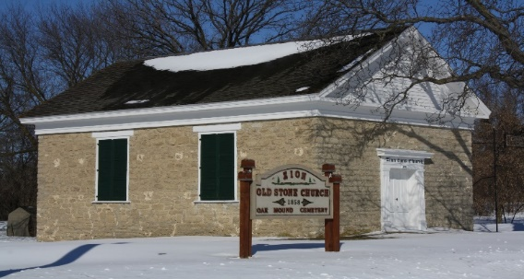

Come enjoy an afternoon of an old-fashioned church service at the **Alto Zion Congregational (Old Stone Church),** 4042 Amity Rd, Brandon. The service is on August 14 at 2 PM with a free-will offering. Refreshments will follow the service.

**Discipleship Bible Study** – ONE Waupun is once again offering the Downline Discipleship Bible study. We led this study 2 years ago and have seen tremendous impact in those that attended. We plan to offer this study to both men and women this time around. This 8-session study will be spread out during the months of September, October and November and will be offered on Tuesday mornings at 6 AM or Wednesday nights at 7 PM. To learn more or to sign up, go to [www.onewaupun.com/grow/discipleship.cfm](http://www.onewaupun.com/grow/discipleship.cfm) or talk to Mike Vander Berg (920-382-5559).

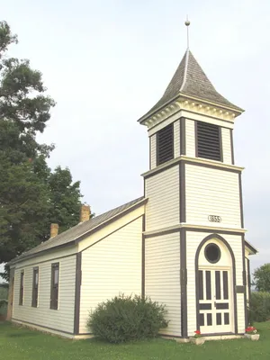

The **Annual Norwegian Church Service at the Norske Evangelical-Lutherske Kirke** (W9616 Church Road, Waupun), originating in 1855, will be held on August 28 at 2 PM. The service will be led by Rev. Dennis Overlien, Chaplain of the Waupun Christian Home. Traditional fellowship time will follow with refreshments. All are welcome. Com to worship and share an afternoon with community near the natural sanctuary of the Horicon Wildlife Refuge.

**Calendar**

**Today:** 9:30 AM Worship Service

**Sunday:** 9:30 AM Worship Service

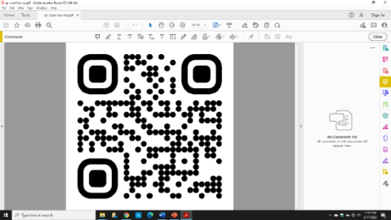

Honor God

Serve Others

Transform Lives

**Next Week**

**Accompanist**

Marlyce Mulder

**Children’s Worship**

Sarah Schuringa, Cassidy Ritzema

**Coffee**

Steve and Heidi Smits

**Nursery**

Andrea Buwalda, Phylicia Coda,

Taylor Hoffman

**Livestream**

Gregg Zonnefeld

**PPT**

Ryer Greenfield

**Sound System**

Joe Bresser

**Ushers**

Cody Van Herwaarden, Brian O’Donovan

|  |  |  |
| --- | --- | --- |
| **Group** | **Elder** | **Deacon** |
| 1 | Keith Buwalda (2025) | Todd Schouten (2024) |
| 2 | Denny Vande Berg (2023) | Tyler Jansen (2025) |
| 3 | Bob Mulder (2025) | Todd Schouten (2024) |
| 4 | George Aalsma (2024) | Mitch Vree (2025) |
| 5 | Dan Scheuers (2025) | Tyler Jansen (2025) |
| 6 | Steve Smits (2023) | Noah Mulder (2023) |
| 7 | Ben Homan (2023) | Pete Vander Werff (2023) |
| 8 | Ray Hofman (2024) | Tyler Ten Pass (2024) |

**Sermon Notes**

